



**A**

**Project Report**

on

## Number Plate Recognition System

submitted as partial fulfillment for the award of

**BACHELOR OF TECHNOLOGY**

**DEGREE**

SESSION 2022-23

in

## Computer Science and Engineering

By

Yuvraj Kashyap (1900290100201)

Suhail Bashir (1900290100164) Sakshi Singh Dhangar (1900290100130)

**Under the supervision of**

Prof. Neha Yadav

**KIET Group of Institutions, Ghaziabad**

Affiliated to

**Dr. A.P.J. Abdul Kalam Technical University, Lucknow**

(Formerly UPTU)

**May, 2023**

**DECLARATION**

We hereby declare that this submission is our own work and that, to the best of our knowledge and belief, it contains no material previously published or written by another person nor material which to a substantial extent has been accepted for the award of any other degree or diploma of the university or other institute of higher learning, except where due acknowledgment has been made in the text.

Signature

Name: Yuvraj Kashyap Roll No.: 1900290100201

Date:

Signature

Name: Suhail Bashir

Roll No.: 1900290100164

Date:

Signature

Name: Sakshi Singh Dhangar Roll No.: 1900290100130

Date:

## CERTIFICATE

This is to certify that Project Report entitled “Number Plate Recognition System” which is submitted by Student name in partial fulfillment of the requirement for the award of degree B. Tech. in Department of Computer Science & Engineering of Dr.

A.P.J. Abdul Kalam Technical University, Lucknow is a record of the candidates own work carried out by them under my supervision. The matter embodied in this report is original and has not been submitted for the award of any other degree.

**Date: Supervisor Name : Neha Yadav**

**(Assistant Prof.)**

## ACKNOWLEDGEMENT

It gives us a great sense of pleasure to present the report of the B. Tech Project undertaken during B. Tech. Final Year. We owe special debt of gratitude to Prof. Neha Yadav, Department of Computer Science & Engineering, KIET, Ghaziabad, for her constant support and guidance throughout the course of our work. Her sincerity, thoroughness and perseverance have been a constant source of inspiration for us. It is only his cognizant efforts that our endeavors have seen light of the day. We also take the opportunity to acknowledge the contribution of Dr. Vineet Sharma, Head of the Department of Computer Science & Engineering, KIET, Ghaziabad, for his full support and assistance during the development of the project. We also do not like to miss the opportunity to acknowledge the contribution of all the faculty members of the department for their kind assistance and cooperation during the development of our project. We also do not like to miss the opportunity to acknowledge the contribution of all faculty members, especially faculty/industry person/any person, of the department for their kind assistance and cooperation during the development of our project. Last but not the least, we acknowledge our friends for their contribution in the completion of the project.

Date:

Signature:

Name : Yuvraj Kashyap Roll No.: 1900290100201

Date:

Signature:

Name: Suhail Bashir

Roll No.: 1900290100164

Date:

Signature:

Name: Sakshi Singh Dhangar

Roll No.: 1900290100130

## ABSTRACT

Object detection and image segmentation is the procedure of object identification and organization. The model in this project is fabricated using YOLO Neural networks. In this project, we hope to achieve the same by training our CNN deep learning network on various datasets such as COCO acronym of Common Object in Context.

The aim of this project is to disclose and classify objects which are fed to our network in different formats (png, jpeg, avi, mp4, etc.) in minimum time as well as maintaining a high accuracy. We see object identification even as backsliding trouble up to graphically bisect bounding containers also similar with class prospect.

Unit neural chain forecasts enclose containers together with class chances immediately from filled pictures in single calculation. Since the entire identification duct or tube happen in a unit grid, it might be reformed everywhere quickly on identification representation. Our combine system is very rapid.

And Picture Segmentation happen in the technique of dividing a computerized picture within many parts. Segmentation, basically define as technique of set a flag to every single pixel inside a picture so that pixels which has same flag have certain properties. And also, in this report we have given a short outline about some segmentation techniques used in picture processing like clustering, edge based, region based, model based, etc.

Our simple YOLO model processes pictures at 45 fps. The small-scale category of the grid, Rapid YOLO, approach at 155 fps. Contrast to state-of-the-art recognition method, YOLO put together many localizations inaccurate still is smaller likely to forecast wrong positives on environment.

Our model structure is stimulated by the Google Net sketch for picture categorization. Our model has twenty-four specified levels following the two fully interconnected levels. Moreover, because of the specific modules taken by Google Net we can use one x one reduction levels followed by three x three convolutional levels. We also coach a rapid type of YOLO created to exceed the limits of rapid entity recognition.

## TABLE OF CONTENTS

**Page No.**

DECLARATION ii

CERTIFICATE iii

ACKNOWLEDGEMENT iv

ABSTRACT v

LIST OF ABBREVIATIONS xi

LIST OF FIGURES xii

LIST OF TABLES xiii

CHAPTER 1 INTRODUCTION 1

* 1.1 INTRODUCTION 1
* 1.2 PROBLEM STATEMENT 3
* 1.3 MOTIVATION 3
* 1.4 SOFTWARE DEVELOPMENT METHODOLOGY - I 3
* 1.6 SOFTWARE DEVELOPMENT METHODOLOGY - II 5

CHAPTER 2 LITERATURE SURVEY 6-7

CHAPTER 3 SOFTWARE REQUIREMENT SPECIFICATION 8

* 3.1 INTRODUCTION 8
* 3.2 INTENDED AUDIENCE AND READING SUGGESTION 9
* 3.3 GENERAL ARCHITECTURE OF SOFTWARE 10
* 3.4 REQUIREMENT SPECIFICATION 12
  + 3.4.1 TYPES OF REQUIREMENTS 12
    - 3.4.1.1 FUNCTIONAL REQUIRMENTS 13
    - 3.4.1.2 NON-FUNCTIONAL REQUIRMENTS 13
  + 3.4.2 PYTHON FILE 14
  + 3.4.3 CREATING AND RUNNING SCRIPT 14
* 3.5 FEASIBILITY STUDY 15
  + 3.5.1 OPERATIONAL FEASIBILITY 15
  + 3.5.2 TECHNICAL FEASIBILITY 15
  + 3.5.3 ECONOMIC FEASIBILITY 16
  + 3.5.4 SCHEDULE FEASIBILITY 16
* 3.6 SYSTEM REQUIREMENT STUDY 17
  + 3.6.1 SYSTEM REQUIREMENTS 17
  + 3.6.2 HARDWARE REQUIREMENTS 18
* 3.7 USER REQUIREMENT DOCUMENT(URD) 19
  + 3.7.1 USE-CASE DIAGRAM 19
  + 3.7.2 ACTIVITY DIAGRAM 22
* 3.8 SYSTEM DESIGN 23
  + 3.8.1 INTRODCUTION 23
  + 3.8.2 DFD-LEVEL 1 DIAGRAM 25
  + 3.8.3 SEQUENCE DIAGRAM 26
  + 3.8.4 CLASS DIAGRAM 27
  + 3.8.5 FLOW CHART 28

CHAPTER 4 METHODOLOGY 30

* 4.1 PLATFORM SLECTION 30
* 4.2 PROGRAMMING LANGYAGE GIST 30
* 4.3 CODING STANDARDS 31
  + 4.3.1 NAMING CONVENTIONS 31
  + 4.3.2 ORGANINZING IMPORTS 31
  + 4.3.3 INDENTATION AND LINE LENGTHS 32
  + 4.3.4 BREAK LINES 32
  + 4.3.5 WHITE SPACE 32
  + 4.3.6 COMMENTS 33
  + 4.3.7 DOCUMENT STRINGS 33

|  |  |  |
| --- | --- | --- |
| 4.4 SCREENSHOTS |  | 35 |
| * CASE 1 |  | 35 |
| * CASE 2 |  | 36 |
| CHAPTER 5 TESTING AND INTEGRATION |  | 37 |
| * A. TYPES OF TESTING |  | 37 |
| * 1. UNIT TESTING |  | 37 |
| * 2. SYSTEM TESTING |  | 37 |
| * 3. PERFORMANCE TESTING |  | 38 |
| * B. VERIFICATION AND VALIDATION |  | 38 |
| * 1. UNIT TESTING |  | 38 |
| * TEST CASES FOR PLATE LOCALISATION |  | 39 |
| * TEST CASES FOR CHARACTER SEGMENTATION | 40 |  |
| * TEST CASES FOR CHARACTER RECOGNITION |  | 41 |
| * 2. SYSTEM TESTING |  | 42 |
| CHAPTER 6 RESULTS AND DISCUSSION |  | 44 |
| CHAPTER 7 CONCLUSION AND FUTURE  ENHANCEMENTS |  | 46 |
| * 7.1 CONCLUSION |  | 46 |
| * 7.2 LIMITATIONS |  | 46 |

* 7.3 FUTURE ENHANCEMENTS 46

REFERNCES 47

APPENDIX 49

## LIST OF ABBREVIATIONS

* **YOLO** – You Only Look Once
* **CNN** – Convolutional Neural Networks
* **COCO** – Common Object in Context
* **DPM** – Data package Manager
* **R-CNN** – Region Convolutional Neural Networks
* **VOC** – Visual object Classes
* **RGB** – Red Green Blue

## LIST OF FIGURES

**Page No.**

* Figure 1.1 – Process flow of Character Recognition 1
* Figure 1.2 – Image after applying YOLO 2
* Figure 1.3 – Image after applying YOLO 4
* Figure 1.4 – Architecture of YOLO CNN 5
* Figure 3.1 – Detailed Architecture of YOLO 11
* Figure 3.2 – Process flow of Character Recognition 12
* Figure 3.3 – Use Case Diagram 21
* Figure 3.4 – Activity Diagram 23
* Figure 3.5 – Process flow for Character Recognition 25
* Figure 3.6 – DFD Diagram 26
* Figure 3.7 – Class Diagram 28
* Figure 3.8 – Flow Chart 29
* Figure 4.1 – Test Case 1 35
* Figure 4.2 – Test Case 2 36
* Figure 6.1 – Confusion Matrix 45

## LIST OF TABLES

**Page No.**

* Table 2 – Test cases for plate localization 39
* Table 3 – Test cases for character segmentation 40
* Table 4 – Test cases for character recognition 42
* Table 5 – Test cases for System Training 43
* Table 6 – Efficiency Matrix 45

## CHAPTER 1 INTRODUCTION

##### INTRODUCTION

The technical world is deploying analysis in intelligent shipment systems which have a larger impact on mankind. License Plate detection is a computer technology to figure out the license number of automobiles from pictures. It is a planted system which has multiple uses and challenges. At instant, the application of automobiles is increasing in the world. All of these automobiles have a specific vehicle detection number as their major identifier. The ID is the license number that is a legal license to take part in the crowdy movement. Each automobile in the globe must have its specific number plate that must be fixed on its body. Typical LPR systems are applied using proprietary technologies which are costly. This concluded approach also prevents further analysis and growth of the system. With the increase of loose and open-source technologies the computing world is raised to fresh peaks. Mankind’s from several communities’ interconnect in multi-cultural surroundings to build solutions for mans never closing troubles. One of the important collections of the open-source community in the technological world is Python.

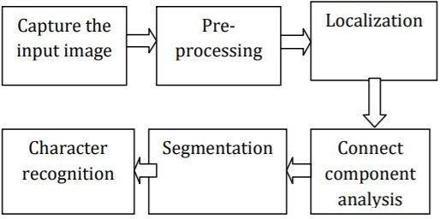

Figure 1.1 – Process flow of Character Recognition

Humans glance at an image and instantly know what objects are in the image, where they are, and how they interact. The human visual system is fast and accurate, allowing us to perform complex tasks like driving with little conscious thought. Fast, accurate, algorithms for object detection would allow computers to drive cars in any weather without specialized sensors, enable assistive devices to convey real-time scene information to human users, and unlock the potential for general purpose, responsive robotic systems.

We reframe object detection as a single regression problem, straight from image pixels to bounding box coordinates and class probabilities. Using our system, you only look once (YOLO) at an image to predict what objects are present and where they are. YOLO is refreshingly simple. A single convolutional network simultaneously predicts multiple bounding boxes and class probabilities for those boxes. YOLO trains on full images and directly optimizes detection performance. This unified model has several benefits over traditional methods of object detection.

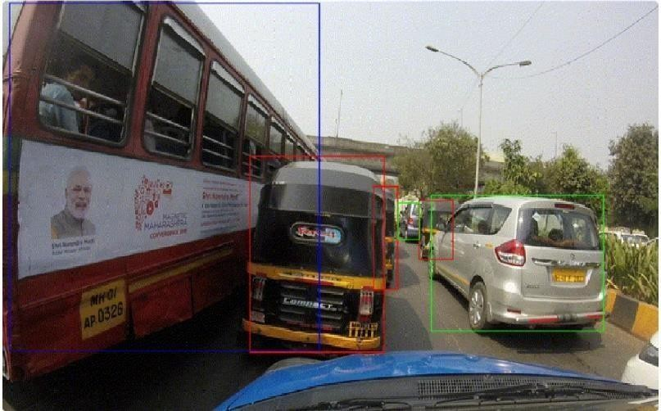

Figure 1.2 – Image after applying YOLO

Intel’s exploration in Computer Vision develops Open Computer Vision (OpenCV) library, which helps in computer vision development. This recognition system assists with safety, automated switching systems, highway automobiles pace spotting, light spotting, steal automobiles spotting, and human and non-human loss collection systems. The automatic license plate recognizing system restore the manual license plate numerical writing procedure in computer systems.

##### PROBLEM STATEMENT

Our project deals with deep learning techniques specifically object detection and image classification in real time to create a working model that will help the blind to understand their environment in a better way. To achieve high accuracy in real time while by training and finetuning our model in an efficient way. Precisely, we want to develop a working software that will predict the exact license plate number of any car comes into the frame with license plate.

##### MOTIVATION

As we all know it is tough for a blind person to live their life without the help of others so here, we are, by using our project blind people who want to explore their nearby areas, can easily explore without being dependent on others for helping them. We can easily direct computers to disclose and classify many objects in a picture with big accuracy. We have to acknowledge the terms such as picture classification object spotting, object localization and lastly inspect an object spotting algorithm known as YOLO acronym for You only look once.

The main concern of this project is building a fast efficient and precise machine learning predictor that can give us the desired output as the characters of number plate of vehicle. This project gave us the basic understanding of the modern neural network and how it works with applications in computer vision. By using the building blocks of neural networks, we were able to improve the accuracy of a model with its pre-trained model. We used our understanding of the pre-defined building model of the neutral network to compare the model accuracy using OpenCV.

##### SOFTWARE DEVELOPMENT METHODOLOGY

Our project is divided into two major components: vehicle detection and license plate character recognition.

Phase I is detecting whether an input contains vehicles or not. If the algorithm predicts that the input contains vehicles, then we need to define a method which will precisely locate and crop the vehicle from the original data. Starting with the output from Phase I as the input.

Phase II should search for the vehicle’s license plate and have the ability to recognize the number on the car plate. Through investigating, we found that vehicle detection is already quite developed and there are numerous existing methods online; however, we still decided to explore deep learning through this project. We attempt to improve the accuracy with some pre-trained models.

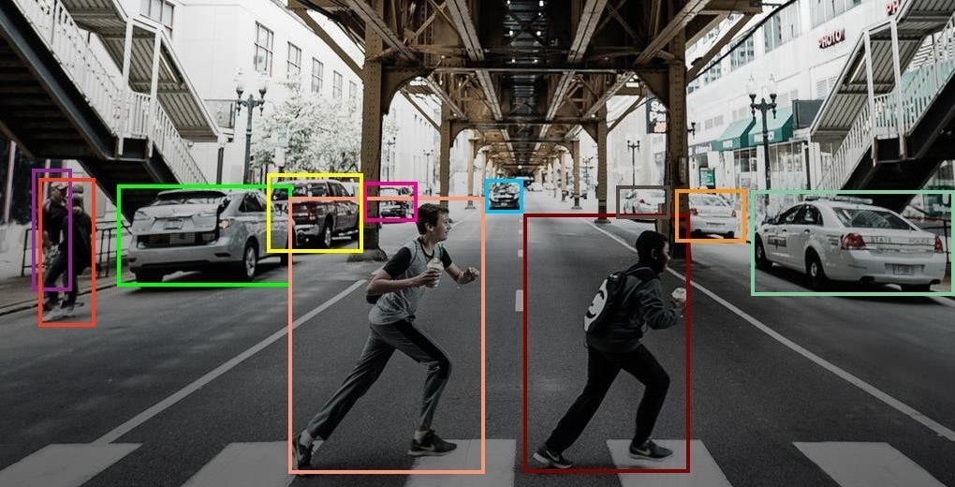

Figure 1.3 – Image after applying YOLO

License Plate Recognition has been widely used in different domains like traffic control, security process, crime detection and automatic parking systems. In recent times LPR has taken a leap into technology easing the work of car detection. Besides all the improvements LPR has made in this modern era there still are problems related to its accuracy, efficiency and processing time.

There are many challenges that affect the process of LPR like poor video quality and meteorological conditions which results in inaccurate results as output. At the same time many projects related to LPR have high processing time and are redundant in real-time execution for traffic monitoring and investigation to tackle this problem our project proposes a real time solution for license plate detection by first detecting the license plate and simultaneously converting the license plate using Optical Character Recognition to character data and sending alerts to all the traffic officials in the nearby signals.

##### SOFTWARE DEVELOPMENT METHODOLOGY

The focus about object identification will reveal all occurrence of the objects amonga familiar class, like individuals, vehicles or face in a picture. Generally, a unique brief group of occurrences of the object are there in picture, still show up a huge group of viable places and measurements around which everybody can appear and that can be inspect. All detection of the picture is mentioned with some form of information. Here it is clear that the place of object, a place along with scale, and area of object explain in the bounding container.[1] In other layout, the intel is better along with the variables of linear or non-linear change such as face recognition intoa face spotter may calculate exact places of eyes, mouth, and nose, in appending to the enclose container of face. A simple example of a bicycle recognition is shown in the picture that defines the places of some segment is shown below in Figure.

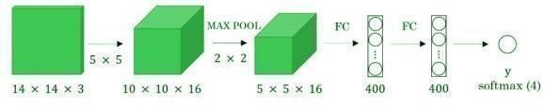

Figure 1.4 – Architecture of YOLO CNN

Talking about scenario of the hard object shown in a picture, at most a single of example might require, however in general several building examples are needed to show some outlook of class flexibility convolutional execution of the sliding screens. Figure depicts how we can change the fully attached layers of the network into the subsequent layers.

## CHAPTER 2 LITERATURE SURVEY

Several studies have focused on optimizing ANPR systems for different environmental conditions, such as night-time or low light conditions, where traditional VLPR techniques may not work well. For example, a recent study proposed using a deep learning-based approach that incorporated night-time images to improve the recognition accuracy of license plates under low-light conditions [5,18]. Some studies have explored the use of deep learning techniques, such as Convolutional Neural Networks (CNNs), for feature extraction and classification in ANPR systems [8]. CNNs have shown promising results in recognizing license plate regions and characters, leading to higher accuracy rates compared to traditional approaches [3] . Another area of research is the integration of ANPR systems with other technologies, such as RFID and GPS, to improve their functionality and enable additional features such as real-time vehicle tracking and location-based services [12,2].

ANPR systems are also being used in various applications, such as parking management and toll collection. For example, a study proposed an ANPR-based parking management system that utilized a machine learning approach to predict parking availability and optimize parking allocation [16] . Despite the significant progress made in ANPR technology, there are still some limitations, such as the need for high-quality images, limited accuracy in recognizing non- standard license plates, and potential privacy concerns [2,7,11]. Researchers continue to work on improving VLPR systems to address these issues and make them more practical and reliable for real-world applications [9] . The system achieved high accuracy on several license plate datasets [7].

Several ANPR techniques have been proposed in the literature, and we have identified the following key approaches:

* + 1. Template Matching: This technique involves comparing the captured license plate image with pre-defined templates to recognize characters. It relies on pixel-level similarity measures for character recognition.[11]
    2. Machine Learning-based Approaches: Machine learning algorithms, such

as Support Vector Machines (SVM), Artificial Neural Networks (ANN), and Convolutional Neural Networks (CNN), have been employed for ANPR. These techniques learn the features and patterns from training datasets to recognize characters accurately.[4]

* + 1. Image Processing-based Approaches: Various image processing techniques, including edge detection, morphological operations, segmentation, and connected component analysis, have been utilized for license plate detection and character recognition.[7,13]

##### OpenCV in ANPR

OpenCV, an open-source computer vision library, has gained significant popularity for ANPR research. It provides a wide range of functions and algorithms that can be leveraged for license plate detection, character segmentation, and recognition. OpenCV offers robust image processing capabilities, contour analysis, feature extraction, and machine learning integration.

##### Advances in ANPR using OpenCV

Researchers have made significant advancements in ANPR using OpenCV. Some notable contributions include:

1. Integration of Deep Learning: Deep learning techniques, particularly Convolutional Neural Networks (CNN), have been successfully applied to ANPR. By training CNN models on large-scale license plate datasets, researchers have achieved improved recognition accuracy.[12]
2. Real-time ANPR Systems: Efforts have been made to develop real-time ANPR systems that can process video streams and capture license plates in real-time scenarios. OpenCV's optimization and parallel processing capabilities have been utilized to achieve real-time performance[16].
3. Enhancement of License Plate Detection: Researchers have proposed novel techniques to improve license plate detection accuracy, including the utilization of advanced edge detection algorithms, contour analysis, and the integration of OpenCV with other computer vision libraries.

## CHAPTER 3

**SOFTWARE REQUIRMENT SPECIFICATION**

##### INTRODUCTION

A **software requirements specification (SRS)** includes in-depth descriptions of the software that will be developed.

A **system requirements specification (SyRS)** collects information on the requirements for a system.

“Software” and “system” are sometimes used interchangeably as SRS. But a software requirement specification provides greater detail than a system requirements specification.

##### Internal Interface requirement:

Identify the product whose software requirements are specified in this document, including the revision or release number. Describe the scope of the product that is covered by this SRS, particularly if this SRS describes only part of the system or a single subsystem. Describe any standards or typographical conventions that were followed when writing this SRS, such as fonts or highlighting that have special significance.

For example, state whether priorities for higher-level requirements are assumed to be inherited by detailed requirements, or whether every requirement statement is to have its own priority.

Describe the different types of reader that the document is intended for, such as developers, project managers, marketing staff, users, testers, and documentation writers. Describe what the rest of this SRS contains and how it is organized. Suggest a sequence for reading the document, beginning with the overview sections and proceeding through the sections that are most pertinent to each reader type.

Provide a short description of the software being specified and its purpose, including relevant benefits, objectives, and goals. Relate the software to corporate goals or

business strategies. If a separate vision and scope document is available, refer to it rather than duplicating its contents here. The recent explosion in data pertaining to users on social media has created a great interest in performing sentiment analysis on this data using Big Data and Machine Learning principles to understand people's interests. This project intends to perform the same tasks. The difference between this project and other sentiment analysis tools is that, it will perform real time analysis of tweets based on hash tags and not on a stored archive.

Describe the context and origin of the product being specified in this SRS. For example, state whether this product is a follow-on member of a product family, a replacement for certain existing systems, or a new, self-contained product. If the SRS defines a component of a larger system, relate the requirements of the larger system to the functionality of this software and identify interfaces between the two. A simple diagram that shows the major components of the overall system, subsystem interconnections, and external interfaces can be helpful.

The product functions are: -

* Conversion of input vehicle RGB image to Grayscale Conversion.
* Image Binarization for converting the image in the from of 0 and 1.
* Edge Detection by Sobel operator followed by Image Morphological operations leads to the actual Number Plate Extraction.
* Now Segmentation of each character and their identification using machine learning model.
* Sort or arrange the character in the order of license plate number.

##### INTENDED AUDIENCE AND READING SUGGESTION

The intended audience for this document are: -

* + - The team members of innovative project *Automatic License Plate Recognition using OpenCV*.
    - All the technical readers and researchers.
    - The project supervisor Dr. Mukesh Rawat.

This document will be reviewed frequently by the above audiences to check if the different phases of the project are being completed by meeting the given requirements.

If there are any changes in the requirements in the course of the project, they must be included in this document by making the necessary changes.

The authors would suggest clients to go through the requirement section thoroughly before installing the software. The lab technicians are expected to have certain knowledge in the terms used and hence can go for the security issues directly. Students and developers can utilize the documentation as a resource in developing the project to a new project.

##### GENERAL ARCHITECTURE OF SOFTWARE

The general architecture of the software consists of: -

* + - Object Extraction by YOLO.

It consists of series of steps to determine whether the object detected is useful for us for not. The architecture of YOLO is shown on the next page.

The bounding box from each of subsequent layers determine the data present in that image. And the final bounding box extract the image or the portion of the image that is required.

We reframe object detection as a single regression problem, straight from image pixels to bounding box coordinates and class probabilities. Using our system, you only look once (YOLO) at an image to predict what objects are present and where they are. YOLO is refreshingly simple. A single convolutional network simultaneously predicts multiple bounding boxes and class probabilities for those boxes. YOLO trains on full images and directly optimizes detection performance. This unified model has several benefits over traditional methods of object detection.

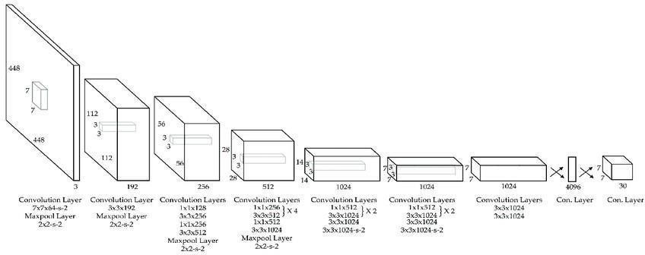

Figure 3.1 – Detailed Architecture of YOLO

* + - Character Segmentation by Image Segmentation

This is done by Designing an ML model and train it with a particular Data Set. The overall work flow can be shown in following diagram: -

License Plate Recognition has been widely used in different domains like traffic control, security process, crime detection and automatic parking systems. In recent times LPR has taken a leap into technology easing the work of car detection. Besides all the improvements LPR has made in this modern era there still are problems related to its accuracy, efficiency and processing time.

The figure on next page shows the process flow diagram of this implementation.

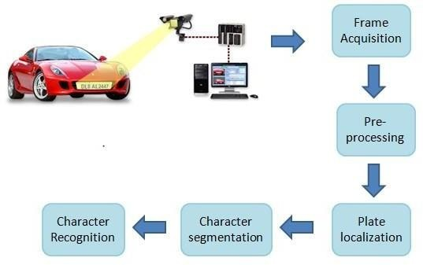

Figure 3.2 – Process Flow of Character Recognition

##### REQUIREMENT SPECIFICATION

A requirement is defined by IEEE (1998) as “a statement that identifies a product or process operational, functional, or design characteristics or constraint, which is unambiguous, testable or measurable, and necessary for product or process acceptability (by consumers or internal quality assurance guidelines).” The requirements should be traceable, manageable, and should have a clear, single understanding, common to all parties involved. A requirement can both define the product that is built in response to the requirements and the processes for using the things that are built (IEEE, 1998).

##### TYPES OF REQUIREMENTS

Requirements can be divided into functional and non-functional requirements, design restrictions and normal, expected and sensational.

##### FUNCTIONAL REQUIREMENTS

Functional requirements state what the system should do, often described by the functions that the system should perform. A common way to express a functional requirement is to specify input and expected output.

* + - * + System should able to detect the Number Plate of the image or video input.
        + System should be able to predict characters up to great efficiency.

##### NONFUNCTIONAL REQUIREMENTS

Non-functional requirements describe how the system should work. The non- functional requirements complement the functional requirements by describing the quality attributes of the system; usability and performance.

* User friendly
* System should provide better accuracy
* To perform with efficient throughput and response time.

##### Performance Requirements:

If there are performance requirements for the product under various circumstances, state them here and explain their rationale, to help the developers understand the intent and make suitable design choices. Specify the timing relationships for real time systems. Make such requirements as specific as possible. You may need to state performance requirements for individual functional requirements or features.

##### Safety Requirements:

Specify those requirements that are concerned with possible loss, damage, or harm that could result from the use of the product. Define any safeguards or actions that must be taken, as well as actions that must be prevented. Refer to any external policies or regulations that state safety issues that affect the product’s design or use. Define any safety certifications that must be satisfied.

##### Security Requirements:

Specify any requirements regarding security or privacy issues surrounding use of the product or protection of the data used or created by the product. Define any user identity authentication requirements. Refer to any external

policies or regulations containing security issues that affect the product. Define any security or privacy certifications that must be satisfied.

##### Software Quality Attributes:

Specify any additional quality characteristics for the product that will be important to either the customers or the developers. Some to consider are: adaptability, availability, correctness, flexibility, interoperability, maintainability, portability, reliability, reusability, robustness, testability, and usability. Write these to be specific, quantitative, and verifiable when possible. At last, clarify the relative preferences for various attributes, such as ease of use over ease of learning.

##### PYTHON FILE

The standard Python installer already associates the .py extension with a file type (Python. File) and gives that file type an open command that runs the interpreter. This is enough to make scripts executable from the command prompt as ‘foo.py’. If you’d rather be able to execute the script by simple typing ‘foo’ with no extension you need to add .py to the PATHEXT environment variable.

* + 1. **CREATING AND RUNNING SCRIPT FILE**

To create scripts files, you need to use a text editor. You can open the python editor in two ways:

* Using the command prompt
* Using the IDE

If you are using the command prompt, type edit in the command prompt. This will open the editor. You can directly type edit and then the filename (with .py extension).

##### FEASIBILITY STUDY

Feasibility study is the preliminary study which investigates the information of prospective users and determines the resources requirements, costs, benefits and feasibility of proposed system. A feasibility study takes into account various constraints within which the system should be implementation such as computing equipment, manpower and costs are estimated. The estimated are compared with available resources and cost benefit analysis of the system is made. The feasibility analysis is activity involves the analysis of the problem and collection of all relevant information relating to the project. The main objectives of the feasibility study are to determine whether the project would be feasible in terms of economic feasibility, technical feasibility and operational feasibility and schedule feasibility or not. It is to make sure that the input data which are required for the project are available. Thus, we evaluated the feasibility of the system in terms of the following categories:

* Technical Feasibility
* Operational Feasibility
* Economic Feasibility
* Schedule Feasibility

##### OPERATIONAL FEASIBILITY

Proposed project is beneficial only if it can be turned into information system that will meet the operating requirements. Simply stated, this test of feasibility asks if the system will work when it is developed and installed. Are the major barriers to Implementation?

The proposed was to make a simplified web application. It is simpler to operate and can be used in any webpages. It is free and not costly to operate.

##### TECHNICAL FEASIBILITY

Evaluating the technical feasibility is the trickiest part of the feasibility study. This is because, at the point in time there is no any detailed designed of the system, making it difficult to access issues like performance, costs(on account of the kind of technology to be deployed) etc. A number of issues have to be considered while doing technical analysis; understand the different technologies involved in the

proposed system. Before commencing the project, we have to be very clear about what are the technologies that are to be required for the development of the new system. Is the required technology available? Our system “Friend affinity Finder” is technically feasible since all the required tools are easily available. Python and JavaScript can be easily handled. Although all tools seem to be easily available but there are challenges too.

##### ECONOMIC FEASIBILITY

Economic feasibility attempts to weigh the costs of developing and implementing a new system, against the benefits that would accrue from having the new system in place. This feasibility study gives the top management the economic justification for the new system. A simple economic analysis which gives the actual comparison of costs and benefits are much more meaningful in this case. In addition, this proves to be useful point of reference to compare actual costs as the project progresses. There could be various types of intangible benefits on account of automation. These could increase improvement in product quality, better decision making and timeliness of information, expending activities, improved accuracy of operations, better documentation and record keeping, faster retrieval of information.

This is a web application. Creation of the application is not costly.

##### SCHEDULE FEASIBILITY

A project will fail if it takes too long to be completed before it is useful. Typically this means estimating how long the system will take to develop, if it can be completed in a given period of time using some methods like payback period. Schedule feasibility is a measure how reasonable the project timetable is. Given our technical expertise, are the project deadlines reasonable? Some project is initiated with specific deadlines. It is necessary to determine whether the deadlines are mandatory or desirable.

A minor deviation can be encountered in the original schedule decided in the beginning of the project. The application development is feasible in terms of schedule.

##### SYSTEM REQUIREMENT STUDY

* + 1. **SOFTWARE REQUIREMENTS:**
       - Python 3 (>= 3.6.1)
       - YOLO (You Only Look Once)
       - Tesseract for OCR
       - OpenCV (for computer vision)

##### Advantages of Python

The diverse application of the Python language is a result of the combination of features which give this language an edge over others. Some of the benefits of programming in Python include:

##### Presence of Third-Party Modules:

The Python Package Index (PyPI) contains numerous third-party modules that make Python capable of interacting with most of the other languages and platforms.

##### Extensive Support Libraries:

Python provides a large standard library which includes areas like internet protocols, string operations, web services tools and operating system interfaces. Many high use programming tasks have already been scripted into the standard library which reduces length of code to be written significantly.

##### Open Source and Community Development:

Python language is developed under an OSI-approved open source license, which makes it free to use and distribute, including for commercial purposes.

Further, its development is driven by the community which collaborates for its code through hosting conferences and mailing lists, and provides for its numerous modules.

##### Learning Ease and Support Available:

Python offers excellent readability and uncluttered simple-to-learn syntax which helps beginners to utilize this programming language. The code style guidelines, PEP 8, provide a set of rules to facilitate the formatting of code. Additionally, the wide base of users and active developers has resulted in a rich internet resource bank to encourage development and the continued adoption of the language.

##### User – friendly Data Structures:

Python has built-in list and dictionary data structures which can be used to construct fast runtime data structures. Further, Python also provides the option of dynamic high-level data typing which reduces the length of support code that is needed.

##### Productivity and Speed:

Python has cleaned object-oriented design, provides enhanced process control capabilities, and possesses strong integration and text processing capabilities and its own unit testing framework, all of which contribute to the increase in its speed and productivity. Python is considered a viable option for building complex multi- protocol network applications.

As can be seen from the above-mentioned points, [Python offers a number of](https://www.invensis.net/it-outsourcing-services/outsource-python-application-development-services/?utm_source=invensis-blog&utm_campaign=blog-post&utm_medium=content-link&utm_term=benefits-of-python-over-other-programming-languages) [advantages for software development.](https://www.invensis.net/it-outsourcing-services/outsource-python-application-development-services/?utm_source=invensis-blog&utm_campaign=blog-post&utm_medium=content-link&utm_term=benefits-of-python-over-other-programming-languages) As upgrading of the language continues, its loyalist base could grow as well.

##### HARDWARE REQUIREMENTS:

* + - * 50 MB HDD
      * GUI Based OS (Microsoft Windows, MacOS, Ubuntu)
      * 500MB Graphics preferred
      * Processor: Intel i5 or more
      * Motherboard: Intel® Chipset Motherboard.
      * Ram: 8GB or more
      * Cache: 512 KB
      * Hard disk: 16 GB hard disk recommended
      * Monitor: 1024 x 720
      * Display Speed: 2.7GHZ and more

##### USER REQUIREMENT DOCUMENT(URD)

The User Requirements Specification describes the business needs for what users require from the system. User Requirements Specifications are written early in the validation process, typically before the system is created. They are written by the system owner and end-users, with input from Quality Assurance. Requirements outlined in the URS are usually tested in the Performance Qualification or User Acceptance Testing. User Requirements Specifications are not intended to be a technical document; readers with only a general knowledge of the system should be able to understand the requirements outlined in the URS.

The URS is generally a planning document, created when a business is planning on acquiring a system and is trying to determine specific needs. When a system has already been created or acquired, or for less complex systems, the user requirement specification can be combined with the functional requirements document.

##### USE-CASE DIAGRAM

A UML use case diagram is the primary form of system/software requirements for a new software program underdeveloped. Use cases specify the expected behavior (what), and not the exact method of making it happen (how). Use cases once specified can be denoted both textual and visual representation (i.e. use case diagram). A key concept of use case modeling is that it helps us design a system from the end user's perspective. It is an effective technique for communicating system behavior in the user's terms by specifying all externally visible system behavior.

##### Actor:

* + - * User

##### Use Case:

* + - * Capture video and acquire image
      * Verify Vehicle
      * Identify Number

##### Precondition:

* + - * A camera is placed at 4-5 m away from the vehicle to get the clear view of the number plate.
      * Videos are captured and stored in a repository.

##### Post condition:

* + - * The license plate numbers are recognized and displayed on the terminal.

A use case diagram doesn't go into a lot of detail—for example, don't expect it to model the order in which steps are performed. Instead, a proper use case diagram depicts a high-level overview of the relationship between use cases, actors, and systems. Experts recommend that use case diagrams be used to supplement a more descriptive textual use case.

UML is the modeling toolkit that you can use to build your diagrams. Use cases are represented with a labeled oval shape. Stick figures represent actors in the process, and the actor's participation in the system is modeled with a line between the actor and use case. To depict the system boundary, draw a box around the use case itself.

UML use case diagrams are ideal for:

* + - * + Representing the goals of system-user interactions.
        + Defining and organizing functional requirements in a system.
        + Specifying the context and requirements of a system.
        + Modeling the basic flow of events in a use case.

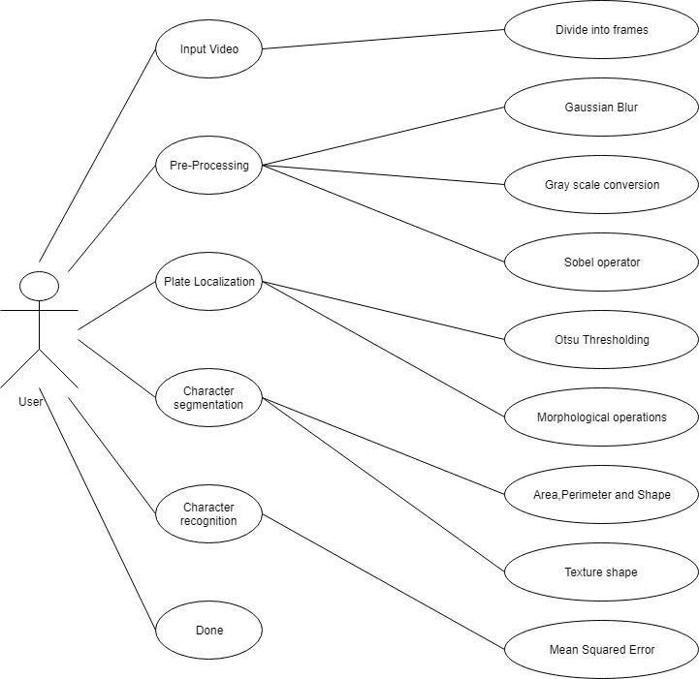

Figure 3.3 – Use Case Diagram

##### ACTIVITY DIAGRAM

Activity diagram is defined as a UML diagram that focuses on the execution and flow of the behavior of a system instead of implementation. It is also called object- oriented flowchart. Activity diagrams consist of activities that are made up of actions which apply to behavioral modeling technology.

Activity diagram is another important diagram in UML to describe the dynamic aspects of the system. Activity diagram is basically a flowchart to represent the flow from one activity to another activity. The activity can be described as an operation of the system. The control flow is drawn from one operation to another.

##### Description:

The main aim behind the number plate recognition is the storage of information of vehicles with respect to its number plate characters. The information thus can be used to track the vehicles.

##### Precondition:

* + - * A camera is placed at 4-5 m away from the vehicle to get the clear view of the number plate.
      * Videos are captured and stored in a repository.

##### Post condition:

* + - * The license plate numbers are recognized and displayed on the terminal.

##### Normal flow of events:

* + - * The camera captures the video of the vehicle.
      * The software identifies and extracts the characters of the number plate of the vehicle and checked for its validity.

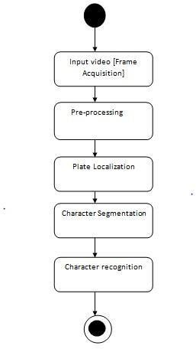

Figure 3.4 – Activity Diagram

##### SYSTEM DESIGN

* + 1. **INTRODUCTION**
* In this project we hope to achieve high accuracy of Object Detection and Image Identification using YOLO and Segmentation.
* The aim of Object Detection is to detect all instances of objects from a known class, such as people, cars or faces in an image.
* Each detection of the image is reported with some form of pose information defined in terms of bounding box.
* With the changing technology and advancement in the field of AI, Object Detection models will play an important role.
* Some of the examples are automated cars, face detection and everything that can be related to understand the environment.

##### COCO Dataset

* + COCO stands for Common Objects in Context.
  + It is a large-scale object detection, segmentation, and captioning dataset.

##### YOLO (You Only Look Once)

* + It unifies the separate components of object detection into a single neural network.
  + The network uses features from the entire image to predict each bounding box.
  + Network has 24 convolutional layers followed by 2 fully connected layers.
  + It uses 1x1 reduction layers followed by 3x3 convolutional layers.
  + Fast YOLO uses fewer convolutional layers (9 instead of 24).
  + The final output of our network is the 7x7x30 tensor of predictions. (S, S, BX5+C = 7, 7, 2X5+20)



Figure 3.5 – Process Flow of Character Recognition

##### DFD-LEVEL 1 DIAGRAM

Also known as DFD, Data flow diagrams are used to graphically represent the flow of data in a business information system. DFD describes the processes that are involved in a system to transfer data from the input to the file storage and reports generation.

Data flow diagrams can be divided into logical and physical. The logical data flow diagram describes flow of data through a system to perform certain functionality of a business. The physical data flow diagram describes the implementation of the logical data flow.

**Video**

**Image frame acquisition**

**Plate localization**

Otsu thresholding Morphological operations

**Character segmentation**

Area, Perimeter, Shape Texture features

**Pre -processing**

Gaussian blur

RGB to gray conversion Sob el edge detection

**Character Recognition**

Mean squared error method

Figure 3.6 – DFD Diagram

##### SEQUENCE DIAGRAM

A sequence diagram simply depicts interaction between objects in a sequential order i.e., the order in which these interactions take place. We can also use the terms event diagrams or event scenarios to refer to a sequence diagram. Sequence diagrams describe how and in what order the objects in a system function. These diagrams are widely used by businessmen and software developers to document and understand requirements for new and existing systems.

##### ALGORITHM

The working of ALPR system consists of the following steps: Step 1: Obtain the frames of a real time video.

Step 2: Pre-process each frame.

Step 3: Perform plate localization on the pre-processed frame based on aspect ratio. Step 4: Extract the individual characters of the license plate.

Step 5: Perform character recognition on the segmented characters and display the result on the terminal.

##### CLASS DIAGRAM

The UML Class diagram is a graphical notation used to construct and visualize object-oriented systems. A class diagram in the Unified Modeling Language (UML) is a type of static structure diagram that describes the structure of a system by showing the system's:

* + - * classes,
      * their attributes,
      * operations (or methods),
      * and the relationships among objects.

The detailed Class diagram of the implementation is given on the next page.

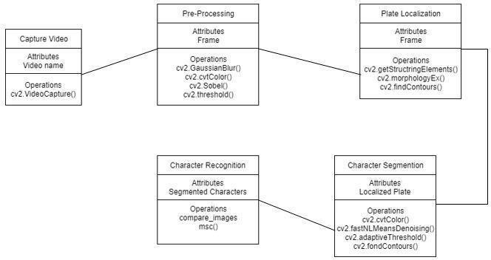

Figure 3.7 – Class Diagram

##### FLOW CHART

A flowchart is a type of diagram that represents a workflow or process. A flowchart can also be defined as a diagrammatic representation of an algorithm, a step-by- step approach to solving a task. The flowchart shows the steps as boxes of various kinds, and their order by connecting the boxes with arrows.

Flowcharts are used in designing and documenting simple processes or programs. Like other types of diagrams, they help visualize what is going on and thereby help understand a process, and perhaps also find less-obvious features within the process, like flaws and [bottlenecks](https://en.wikipedia.org/wiki/Bottleneck_(production)). There are different types of flowcharts: each type has its own set of boxes and notations. The two most common types of boxes in a flowchart are:

* A processing step, usually called *activity*, and denoted as a rectangular box.
* A decision, usually denoted as a diamond.

A flowchart is described as “cross-functional” when the chart is divided into different vertical or horizontal parts, to describe the control of different organizational units. A symbol appearing in a particular part is within the control of that organizational unit. A cross-functional flowchart allows the author to correctly locate the responsibility for performing an action or making a decision, and to show the responsibility of each organizational unit for different parts of a single process.

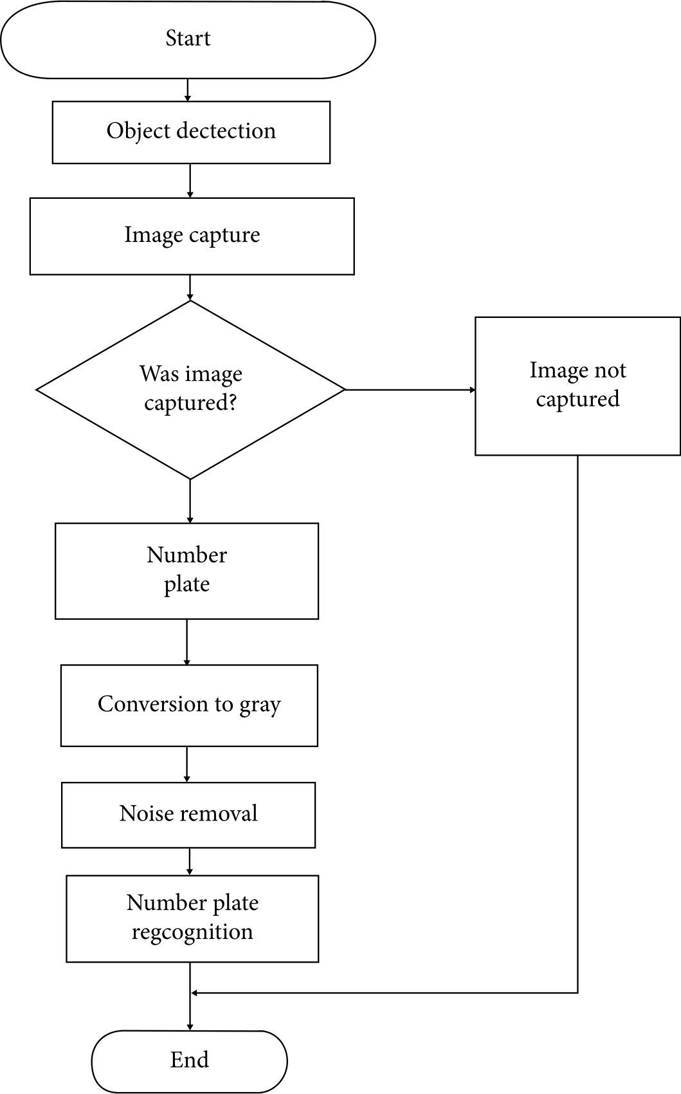

Figure 3.8 – Flow Chart

## CHAPTER 4 METHODOLOGY

##### PLATFORM SELECTION

IDLE (short for integrated development environment or integrated development and learning environment) is an [integrated development environment](https://en.wikipedia.org/wiki/Integrated_development_environment) for [Python,](https://en.wikipedia.org/wiki/Python_(programming_language)) which has been bundled with the default implementation of the language since 1.5.2b1. It is packaged as an optional part of the Python packaging with many [Linux](https://en.wikipedia.org/wiki/Linux_distributions) [distributions.](https://en.wikipedia.org/wiki/Linux_distributions) It is completely written in Python.

IDLE is intended to be a simple [IDE](https://en.wikipedia.org/wiki/Integrated_development_environment) and suitable for beginners, especially in an educational environment. To that end, it is cross-platform, and avoids feature clutter.

According to the included [README,](https://en.wikipedia.org/wiki/README) its main features are:

* Multi-window text editor with [syntax highlighting,](https://en.wikipedia.org/wiki/Syntax_highlighting) autocompletion, smart indent and other.
* Python shell with syntax highlighting.
* Integrated debugger with [stepping,](https://en.wikipedia.org/wiki/Program_animation) persistent [breakpoints,](https://en.wikipedia.org/wiki/Breakpoint) and call stack visibility.

IDLE has been criticized for various usability issues, including losing focus, lack of copying to clipboard feature, lack of line numbering options, and general user interface design; it has been called a "disposable" IDE, because users frequently move on to a more advanced IDE as they gain experience.

##### PROGRAMMING LANGUAGE GIST

Python is an interpreted, object-oriented, high-level programming language with dynamic semantics. Its high-level built-in data structures, combined with dynamic typing and dynamic binding, make it very attractive for Rapid Application Development, as well as for use as a scripting or glue language to connect existing components together. Python's simple, easy to learn syntax emphasizes readability and therefore reduces the cost of program maintenance. Python supports modules and packages, which encourages program modularity and code reuse. The Python

interpreter and the extensive standard library are available in source or binary form without charge for all major platforms and can be freely distributed.

##### CODING STANDARDS

##### NAMING CONVENTIONS

Module Names: – Short, lowercase names, without underscores. Example: myfile.py

Class Names: – CapWords convention. Example: MyClass

Exception Names: – If a module defines a single exception raised for all sorts of conditions, it is generally called "Error". Otherwise use CapWords convention (i.e. MyError.)1.

Method Names and Instance Variables: – The “Style Guide for Python Code” recommends using lowercase with words separated by underscores (example: my_variable). But since most of the code uses mixedCase, recommend using this style (example: myVariable ) – Use one leading underscore only for internal methods and instance variables (i.e. protected).

Example:

_myProtectedVar – Use two leading underscores to denote class-private names Example: myPrivateVar – Don’t use leading or trailing underscores for public attributes unless they conflict with reserved words, in which case, a single trailing underscore is preferrable (example: class _ )

##### ORGANIZING IMPORTS

They should be always put at the top of the file, just after any module comments and document strings, and before module global and constants. Imports should be on separate lines.

Wrong: import sys, os Right: import sys import os

The following is OK, though: from types import String Type, List Type

Imports should be grouped in the following order with a blank line between each group of imports: – standard library imports – related major package imports – application specific imports.

##### INDENTATION AND LINE LENGTHS

Indentions: – 2 spaces (no tabs!) – Avoid using more than five levels of indention. Line length: – Maximum of 72 characters (never exceed 79 characters) – You can break a long line using “\”.

##### BREAK LINES

Leave one line between functions in a class. Extra blank lines may be used to separate groups of related functions. Blank lines may be omitted between a bunch of related one-liners. Use blank lines in functions, sparingly, to indicate logical sections.

##### WHITE SPACE

Multiple statements on the same line are discouraged. WRONG: if foo == 'blah': doBlahThing() CORRECT: if foo == 'blah': doBlahThing()

No white space immediately before an open parenthesis. WRONG: spam (1)

CORRECT: spam(1)

WRONG: dict ['key'] = list [index] CORRECT: dict['key'] = list[index]

No white space inside parentheses, brackets or braces. WRONG: spam( ham[ 1 ], { eggs: 2 } )

CORRECT: spam(ham[1], {eggs:2}) ƒ

No white space immediately before a comma, semicolon, or colon. WRONG: if x == 4 : print x , y ; x , y = y , x

CORRECT: if x == 4: print x, y; x, y = y, x 17 White Space (cont.) ƒ

No more than one space around an operator. WRONG: x = 1 yVal = 2 longVariable = 3

CORRECT: x = 1 yVal = 2 longVariable = 3 18 White Space (cont.) ƒ

Always surround the following operators with a single space on either side – assignment

(=) – comparisons (==, , !=, <>, <=, >=, in, not in, is, is not) – Booleans (and, or, not) –

Arithmetic operators (+, -, *, /, %) WRONG: if (x==4)or(x==5): x=y+5

CORRECT: if (x == 4) or (x == 5): x = y + 5 19 White Space (cont.) ƒ Don't use spaces around the '=' sign when used to indicate a keyword argument or a default parameter value.

WRONG: def complex(real, imag = 0.0): return magic(r = real, i = imag) CORRECT: def complex(real, imag=0.0): return magic(r=real, i=imag)

##### COMMENTS

Block Comments: They are indented to the same level as the code they apply to. Each line of a block comment starts with a # and a single space. Paragraphs inside a block comment are separated by a line containing a single #. Block comments are best surrounded by a blank line above and below them Example: # Compensate for border. This is done by incrementing x # by the same amount x += 1 25

Inline Comments: They should start with a # and a single space. Should be separated by at

least two spaces from the statement they apply to. Example: x += 1 # Compensate for border.

##### DOCUMENT STRINGS

Write document strings for all public modules, functions, classes, and methods. Document strings are not necessary for nonpublic methods, but you should have a comment that describes what the method does. This comment should appear after the "def" line. Insert a blank line before and after all document strings that document a class.

One-line Document strings: The opening and closing """ are on the same line. – There is no blank line either before or after the document string. Describes the function or method's effect as a command ("Do this", "Return that"), not as a description.

Multi-line Document strings: – The """ that ends a multiline document string should be on a line by itself. – Script: The document string of a script should be usable as its "usage" message. It should document the script's function, the command line syntax, and the environment variables. – Module: The document string for a module should generally list the classes, exceptions and functions (and any other objects) that are exported by the module, with a one-line summary of each.

Class: The document string for a class should summarize its behavior and list the public methods and instance variables. If the class is intended to be sub classed, and has an additional interface for subclasses, this interface should be listed separately. If a class subclasses another class and its behavior is mostly inherited from that class, its document string should mention this and summarize the differences. The class constructor should be documented in the document string for its init method. Function or method: The document string should summarize its behavior and document its arguments, return value, side effects, exceptions raised, and restrictions on when it can be called. Optional arguments should be indicated. Use the verb "override" to indicate that a subclass method replaces a super class method and does not call the super class method; use

the verb "extend" to indicate that a subclass method calls the super class method. The document string should contain a summary line, followed by a blank line, followed by a more elaborate description.

## SCREENSHOTS

##### CASE 1

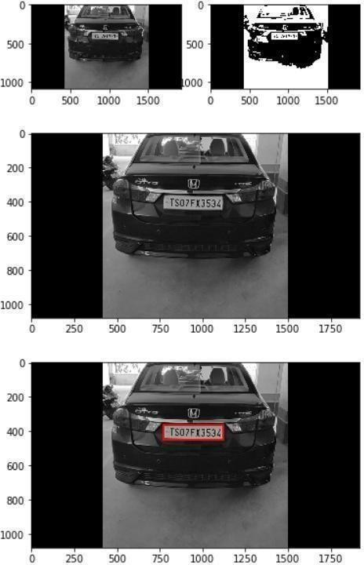

Figure 4.1 – Test Case 1

##### CASE 2

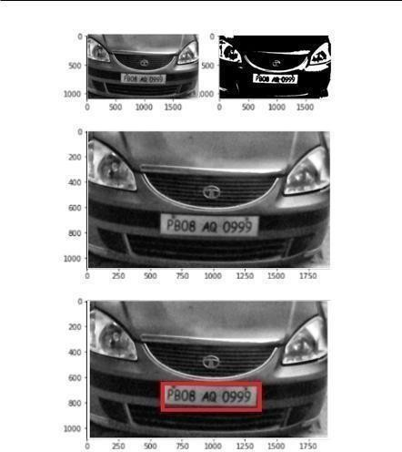

Figure 4.1 – Test Case 2

## CHAPTER 5 TESTING AND INTEGRATION

##### A.TYPES OF TESTING

1. **UNIT TESTING**

Unit testing is performed for testing modules against detailed design. Inputs to the process are usually compiled modules from the coding process. Each modules are assembled into a larger unit during the unit testing process. Testing has been performed on each phase of project design and coding. We carry out the testing of module interface to ensure the proper flow of information into and out of the program unit while testing. We make sure that the temporarily stored data maintains its integrity throughout the algorithm's execution by examining the loc al data structure. Finally, all error-handling paths are also tested.

##### SYSTEM TESTING

We usually perform system testing to find errors resulting from unanticipated interaction between the sub-system and system components. Software must be tested to detect and rectify all possible errors once the source code is generated before delivering it to the customers. For finding errors, series of test cases must be developed which ultimately uncover all the possibly existing errors. Different software techniques can be used for this process. These techniques provide systematic guidance for designing test that

* + Exercise the internal logic of the software components,
  + Exercise the input and output domains of a program to uncover errors in program function, behavior and performance.

We test the software using two methods: White Box testing: Internal program logic is exercised using this test case design techniques. Black Box testing: Software requirements are exercised using this test case design techniques. 30 Both techniques help in finding maximum number of errors with minimal effort and time.

##### PERFORMANCE TESTING

It is done to test the run-time performance of the software within the context of integrated system. These tests are carried out throughout the testing process. For example, the performance of individual module is accessed during white box testing under unit testing.

##### B. VERIFICATION AND VALIDATION

The testing process is a part of broader subject referring to verification and validation. We have to acknowledge the system specifications and try to meet the customer’s requirements and for this sole purpose, we have to verify and validate the product to make sure everything is in place. Verification and validation are two different things. One is performed to ensure that the software correctly implements a specific functionality and other is done to ensure if the customer requirements are properly met or not by the end product. Verification is more like 'are we building the product right?' and validation is more like 'are we building the right product?’

##### UNIT TESTING

Unit testing is a software testing method by which individual units of source code, sets one or more computer program modules together with associated control data, usage procedures and operating procedures are tested to determine if they are fit for use.

Intuitively, one can view a unit as the smallest testable part of an application. In procedural programming, a unit could be an entire module, but it is more commonly an individual function or procedure. In object-oriented programming, a unit is often an entire interface, such as a class, but could also be an individual method.

##### TEST CASES FOR PLATE LOCALISATION

|  |  |  |  |  |  |  |  |  |
| --- | --- | --- | --- | --- | --- | --- | --- | --- |
| **Test Case description** | | **Input** | | **Expected output** | **Output** | | **Status** | |
| Plate detection for back view of the car | |  | |  |  | | Pass | |
| Plate detection for back view of the car | |  | |  |  | | Pass | |
| Plate detection for front  view of the car and inclined plate |  | |  | | |  | | Pass |
| Plate detection for front  view of the car |  | |  | | |  | | Pass |

Table 2 - Test cases for plate localization

##### TEST CASES FOR CHARACTER SEGMENTATION

|  |  |  |  |  |
| --- | --- | --- | --- | --- |
| **Test Case description** | **Input** | **Expected output** | **Output** | **Status** |
| Character segmentation for license  plate with yellow background |  | Individual characters separated out. |  | Pass |
| Character segmentation for license  plate with yellow background |  | Individual characters separated out. |  | Pass |

|  |  |  |  |  |
| --- | --- | --- | --- | --- |
| Character segmentation for license  plate with black background |  | Individual characters separated out. |  | Pass |
| Character segmentation for license  plate with black background |  | Individual characters separated out. |  | Fail (First characte r is missing) |

Table 3 - Test cases for character segmentation

##### TEST CASES FOR CHARACTER RECOGNITION

|  |  |  |  |  |  |
| --- | --- | --- | --- | --- | --- |
| **Test Case description** | **Input** | **Expected output** | **Output** |  | **Status** |
| Recognition  of  segmented characters |  | 53NPRR |  |  | Pass |

|  |  |  |  |  |
| --- | --- | --- | --- | --- |
| Recognition  of  segmented characters |  | 63LDLG |  | Pass |
| Recognition  of  segmented characters |  | JGH5337 |  | Pass |

|  |  |  |  |  |
| --- | --- | --- | --- | --- |
| Recognition  of  segmented characters |  | JGG2373 |  | Fail |

Table 4 - Test cases for character recognition

##### SYSTEM TESTING

System Testing (ST) is a black box testing technique performed to evaluate the complete system the system's compliance against specified requirements. In System testing, the functionalities of the system are tested from an end-to-end perspective.

System Testing is usually carried out by a team that is independent of the development team in order to measure the quality of the system unbiased. It includes both functional and Non-Functional testing.

|  |  |  |  |  |
| --- | --- | --- | --- | --- |
| **Test Case description** | **Input** | **Expected output** | **Output** | **Status** |
| Video is given as input for recognizing characters  of license plate |  | 53NPRR |  | Pass |

|  |  |  |  |  |
| --- | --- | --- | --- | --- |
| Video is given as input for recognizing characters  of license plate |  | 63LDLG |  | Pass |
| Video is given as input for recognizing characters  of license plate |  | JGH5337 |  | Pass |
| Video is given as input for recognizing characters  of license plate |  | JGG2373 |  | Fail |

Table 5 - Test cases for System Testing

## CHAPTER 6 RESULTS AND DISCUSSION

##### 6.1 RESULTS

The algorithm was tested using different license plates having various background conditions, light condition and video quality. The results for character recognition are shown in Table 7.1.

For calculating the precision and recall values we need to know the concepts of

*true positive, false-positive* and false-negative.

* The positive class is confirmed by all the text in output file, all the “recognized” text, correctly or incorrectly recognized.
* The true-negative items are the ones which are correctly rejected. (Ex: 53-NP- RR : Hyphens are correctly rejected as non-characters and the final output is 53NPRR)
* The true-positive items are the ones correctly labeled as belonging to the positive class. So, in this case, the true-positive items are the correctly recognized characters by ANPR software. That will be the characters that are present in both the ground truth file and the program’s output file.
* The false-positives are the items incorrectly labeled as belonging to the positive class; in this case, all the incorrectly recognized characters.
* The false-negatives are items that are not labeled as belonging to the positive class but should have been. In this case, the false-negatives are all the characters that are in the image but didn’t get recognized, i.e., all the characters in the ground truth file that are not present in program’s output file.

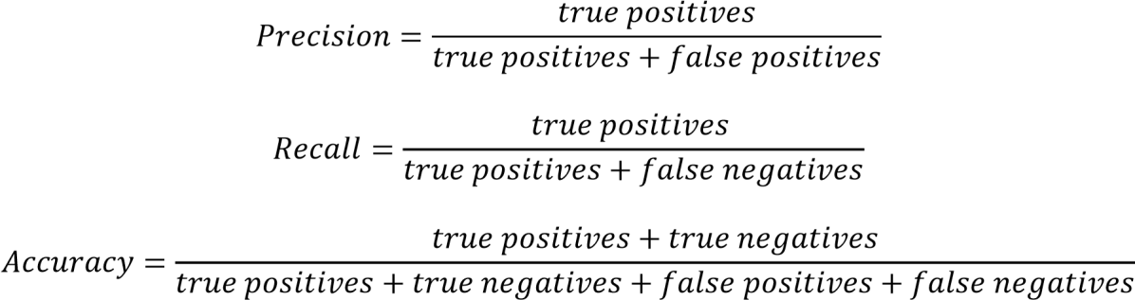

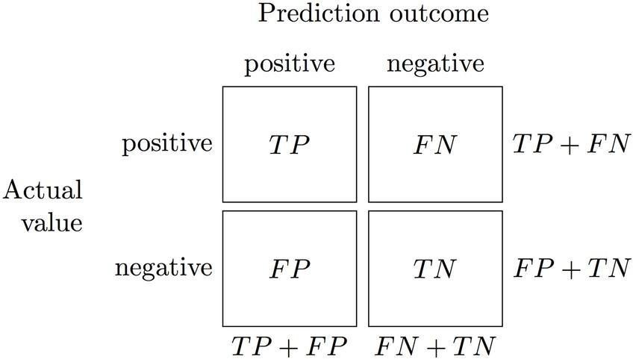

Fig 6.1 Confusion matrix

|  |  |  |  |  |
| --- | --- | --- | --- | --- |
| **Actual plate** | **Predicted**  **plate** | **Precision** | **Recall** | **Accuracy** |
|  | 53NPRR | 6/(6+0) =  100% | 6/(6+0) = 100% | (6+2)/(6+2+0+0)  = 100% |
|  | 63LDLG | 6/(6+0) =  100% | 6/(6+0) = 100% | (6+2)/(6+2+0+0)  = 100% |
|  | JGH5337 | 7/(7+0) =  100% | 7/(7+0) = 100% | (7+0)/(7+0+0+0)  = 100% |
|  | GG2373 | 6/(6+0) =  100% | 6/(6+1)=85.71% | (6+0)/(6+0+0+1)  = 85.71% |

**Average 100% 96.42% 96.42%**

Table 6 – Efficiency Matrix

## CHAPTER 7

**CONCLUSION AND FUTURE ENHANCEMENTS**

##### CONCLUSION

ALPR applications are becoming increasingly complex in Indian context with the phenomenal exponential growth in car, two-wheeler and auto Industries. ALPR applications like automatic toll collection, automatic charging system in parking spaces, management vehicles in parking spaces, and traffic monitoring, etc., have posed new research tasks in ALPR with newer dimensions. We have developed a software for automatic license plate recognition by taking inputs from live video feed. Character segmentation has been implemented on extracted number plates. Finally, segmented characters are recognized by using mean squared error method.

##### LIMITATIONS

* + - Camera should be of good quality. Otherwise, correct text from image would not be extracted properly.
    - There should be proper lighting.
    - This system does not respond properly under different illumination conditions.
    - Although accuracy is high, mean squared error leads to low computational results.

##### FUTURE ENHANCEMENTS

The implementation of the proposed system can be extended for the recognition of number plates of multiple vehicles in a single image frame. User friendly android applications can be developed for traffic surveillance management systems. Also, character recognition can be done using various deep learning algorithms as they yield more accuracy. GPUs can be used to achieve more performance in terms of computational time.

## REFRENCES

1. Joseph Redmon, Santosh Divvala, Ross Girshick, \You Only Look Once: Uni-ed, Real- Time Object Detection”, The IEEE Conference on Computer Vision and Pattern Recognition (CVPR), 2016, pp. 779-788.
2. YOLO Juan Du1,Understanding of Object Detection Based on CNN Family, New Research, and Development Center of Hisense, Qingdao

266071, China.

1. Matthew B. Blaschko Christoph H. Lampert, \Learning to Localize Objects with Structured Output Regression", Published in Computer Vision in 2015.
2. M. J. Islam, S. Basal amah, M. Ahmadi, and M. A. S. hmed, "Capsule image segmentation in pharmaceutical applications using edge-based techniques," IEEE International Conference on Electro/Information Technology (EIT), pp. 1-5, 2011.
3. M. SHARIF, M. RAZA, and S. MOHSIN, "Face recognition using edge information and DCT, Sindh Univ. Res. Jour. (Sci. Ser.), vol. 43, no. 2, pp. 209-214, 2011.
4. W. Haider, "A hybrid method for edge continuity based on Pixel Neighbors Pat-tern Analysis (PNPA) for remote sensing satellite images, Int’l J. of Communications, Network and System Sciences, vol. 5, pp. 624-630, 2012.
5. ] D. Barbosa, "B-spline explicit active surfaces: An e-client framework for real-time 3-D region-based segmentation," IEEE Transactions on Image Processing, vol. 21, pp. 241- 251, 2012.
6. Balasubramanian, M., & Sundaram, S. (2019). Automatic Number Plate Recognition using OpenCV and OCR. International Journal of Innovative Technology and Exploring Engineering, 8(8S), 207-211.
7. Rong, J., Wang, X., & Gao, J. (2017). Automatic license plate recognition using OpenCV and improved segmentation algorithm. In 2017 4th International Conference on Systems and Informatics (ICSAI) (pp. 1481-1485). IEEE.
8. Venkatesan, V. R., & Vasudevan, R. (2016). Automatic number plate recognition system using OpenCV. In 2016 International Conference on Circuit, Power and Computing Technologies (ICCPCT) (pp. 1-5). IEEE.
9. Gupta, A., & Gupta, R. (2016). A review of automatic number plate recognition. International Journal of Advanced Research in Computer Science, 7(5), 131-135.
10. Prabhakar, N., Gupta, R., & Uchil, A. (2017). ANPR using OpenCV and Tesseract OCR. In 2017 International Conference on Intelligent Computing and Control Systems (ICICCS) (pp. 1019-1023). IEEE.
11. Jangir, S., & Saini, R. K. (2019). License plate recognition system using OpenCV and machine learning. In 2019 6th International Conference on Computing for Sustainable Global Development (INDIACom) (pp. 1969-1973). IEEE.
12. Ji, S., Wu, X., & Qiao, Y. (2021). License plate recognition system based on OpenCV and SVM. In 2021 3rd International Conference on Computer Science and Application Engineering (CSAE) (pp. 71-75). IEEE.
13. Zhang, L., Chen, Y., Chen, Z., & Chen, B. (2019). Automatic number plate recognition system based on OpenCV and CNN. In 2019 IEEE 2nd International Conference on Electronic Information and Communication Technology (ICEICT) (pp. 338-342). IEEE.
14. Abdalla, M. A., Mohammed, F. A., & Mohammed, M. A. (2020). Automatic number plate recognition using OpenCV and support vector machine. In 2020 11th International Conference on Information Technology (ICIT) (pp. 69-73). IEEE.

**LIBRARIES RQUIRED**

## APPENDIX

Cycler version 0.10.0

Decorator version 4.4.2

Imageio version 2.8.0

Imutils version 0.5.3

Joblib version 0.15.1

Kiwisolver version 1.2.0

Matplotlib version 3.2.1

Network version 2.4

Numpy version 1.18.4

opencv-python version 4.2.0.34

Pillow version 7.1.2

Pyparsing version 2.4.7

python-dateutil version 2.8.1

PyWavelets version 1.1.1

scikit-image version 0.17.2

scikit-learn version 0.23.1

scipy version 1.4.1

six version 1.15.0

threadpoolctl version 2.0.0

tifffile version 2020.5.25

##### DetetPlate.py

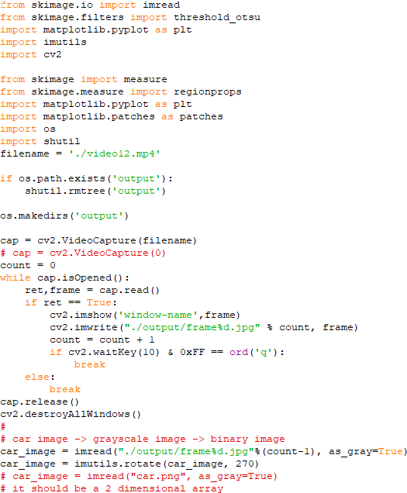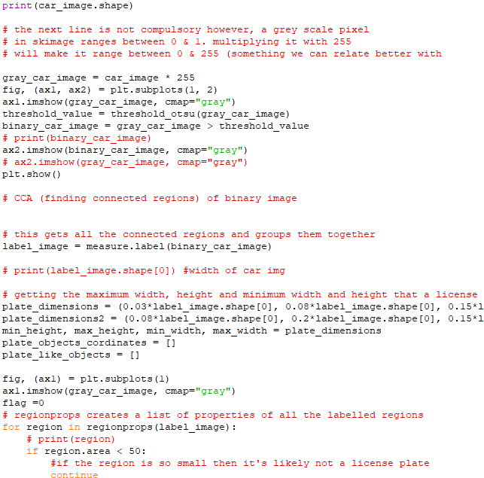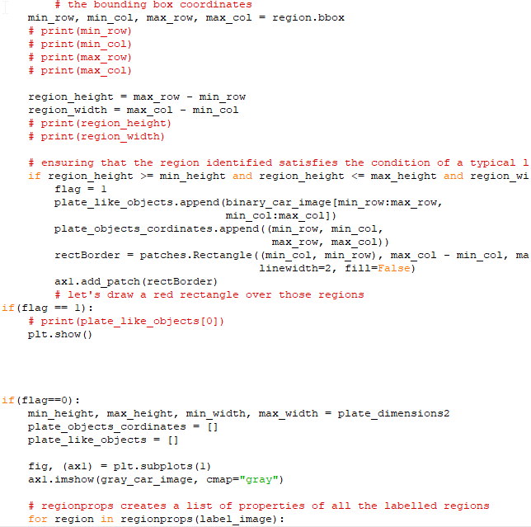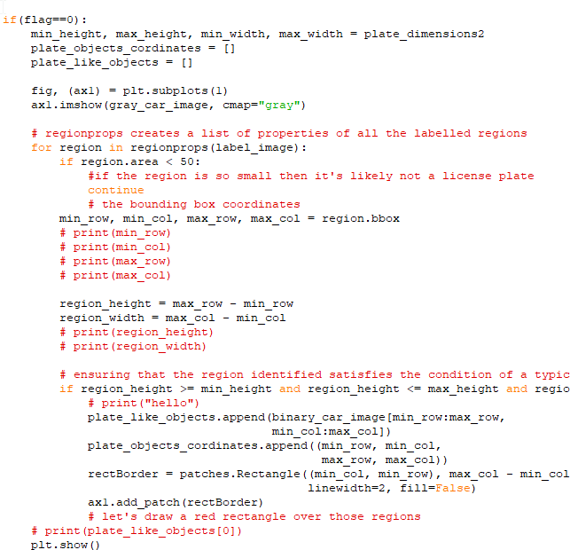

**DetectPlate.py End**

##### SegmentCharacters.py

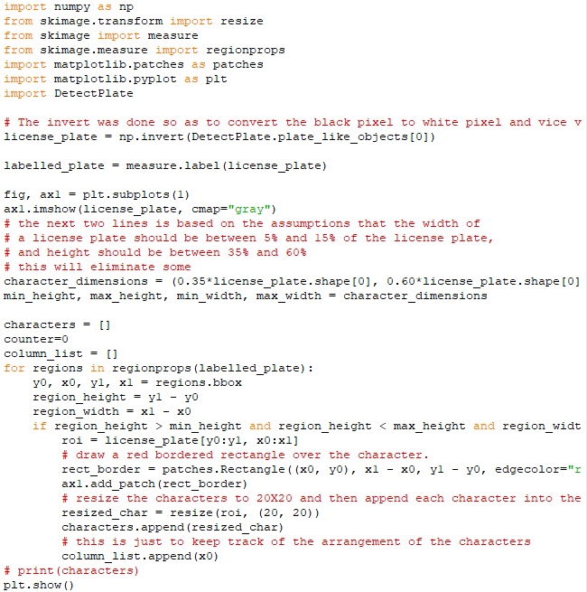

**SegmentCharacters.py End**

##### TrainRecognizeCharacters.py

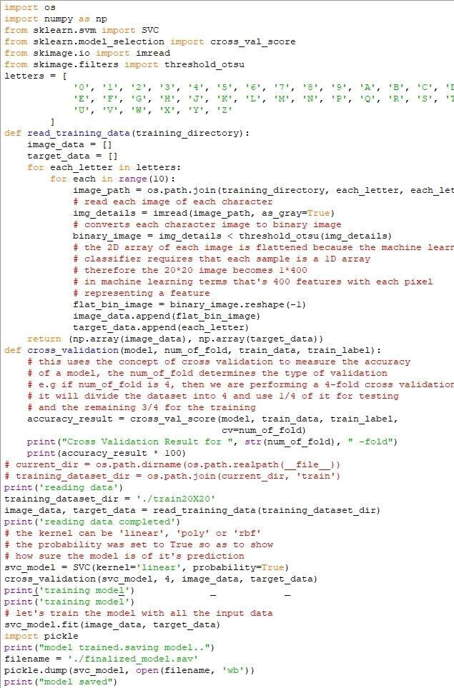

**TrainRecognizeCharacters.py End**

##### PredictCharacters.py

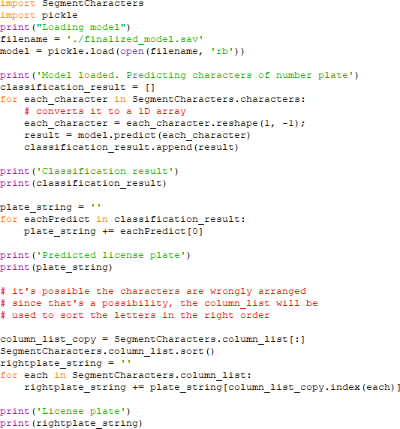

**PredictCharacters.py End**

Ms. Neha Yadav

***Vehicle License Plate Recognition System using Open-CV***

Yuvraj Kashyap

Suhail Bashir

(VLPR)

*Computer Science and Engineering KIET Group of Institutions* Ghaziabad, India [neha.yadav@kiet.edu](mailto:neha.yadav@kiet.edu)

Sakshi Singh Dhangar

*Computer Science and Engineering KIET Group of Institutions* Ghaziabad, India [sakshi.1923cs1124@kiet.edu](mailto:sakshi.1923cs1124@kiet.edu)

*Computer Science and Engineering KIET Group of Institutions* Ghaziabad, India [yuvraj.1923cs1085@kiet.edu](mailto:yuvraj.1923cs1085@kiet.edu)

*Computer Science and Engineering KIET Group of Institutions* Ghaziabad, India [suhail.1923cs1040@kiet.edu](mailto:suhail.1923cs1040@kiet.edu)

***Abstract*— *Vehicle License Plate Recognition (VLPR) is a real-time computer vision technique that identifies and extracts license plate information from vehicles. In this paper, we unveil a strategy VLPR using Open-CV library. The proposed system comprises of several steps, including image pre- processing, license plate detection , character segmentation and character recognition. The effectiveness of the alleged system was assessed using a dataset of license plate images and the results show that the system can accurately identify license plate numbers .We see object identification indeed as backsliding trouble up to graphically bisect bounding holders also akin with class prospect. Unit neural chain vaticinators enclose holders together with class chances incontinently from filled portrays in sole math. Since whole identification tube occurs in a unit grid, it might be redeemed far and wide snappily on identification representation. Our unite system is veritably high-speed.***

***Keywords— license plate, YOLO(You Look Only Once), Open- CV, Machine Learning***

* 1. INTRODUCTION

VLPR is an engineering science that enables the computer to read and recognize license plate numbers. This technology has an extensive repertoire of utilization, such as traffic management, vehicle tracking, and security surveillance [1,6]. ALPR systems can perform real-time license plate recognition in various conditions, such as night- time, rain, or even low light conditions. In this research paper, the authors aim to demonstrate the implementation of ALPR using Open-CV and YOLO [2,4,5].

Open-CV is an open-source computer vision library that caters a comprehensive set of algorithms and tools for image processing and computer vision. Open-CV is widely used in various computer vision applications, such as object detection, face recognition , and image processing [4,7] Open-CV is a gratis, open-source software library to build and deploy computer vision systems. Open-CV has a large community of developers and users that contribute to its development and maintenance[8].

YOLO (You Only Look Once) is an actual time object detection system that can reveal various objects in an image or video. YOLO is fast and efficient and can detect objects in real-time. YOLO utilizes a deep neural network to perform object detection and classification. YOLO is trained on a

large dataset of images to learn the features of various objects, such as cars, bicycles, and pedestrians [6,9].

There are many challenges faced in Object Recognition like Variability in Plate fonts , colors , and illumination , Blockage and partial observability of license plates, Distortion and alignment of license plates, Interference from surrounding object and environment, Processing large amounts of data in real-time, Handling different plate formats and dimensions across regions, Distinguishing between similar characters and recognizing distorted characters, Adapting to varying conditions such as weather

,light ,and motion.

* 1. LITERATURE SURVEY

Several studies have focused on optimizing VLPR systems for different environmental conditions, such as night-time or low light conditions, where traditional VLPR techniques may not work well. For example, a recent study proposed using a deep learning-based approach that incorporated night-time images to improve the recognition accuracy of license plates under low-light conditions [5,18]. Some studies have explored the use of deep learning techniques, such as Convolutional Neural Networks (CNNs), for feature extraction and classification in ANPR systems [8]. CNNs have shown promising results in recognizing license plate regions and characters, leading to higher accuracy rates compared to traditional approaches [3] . Another area of research is the integration of ANPR systems with other technologies, such as RFID and GPS, to improve their functionality and enable additional features such as real-time vehicle tracking and location-based services [12,20].

VLPR systems are also being used in various applications, such as parking management and toll collection. For example, a study proposed an ANPR-based parking management system that utilized a machine learning approach to predict parking availability and optimize parking allocation [16] . Despite the significant progress made in VLPR technology, there are still some limitations, such as the need for high-quality images, limited accuracy in recognizing non-standard license plates, and potential privacy concerns [2,7,11]. Researchers continue to work on

improving VLPR systems to address these issues and make them more practical and reliable for real-world applications

[9] . The system achieved high accuracy on several license plate datasets [7] .

* 1. METHODOLOGY (DETECTION PROCESS)

(VLPR)

probabilities for objects in an image. In the context of VLPR, YOLO can be used to detect and locate license plates within an image or video stream, which is an important step in the overall ANPR pipeline[4,9,11,19].

The use of YOLO in VLPR can improve the accuracy and efficiency of license plate detection compared to traditional methods. For example, YOLO can accurately detect and localize license plates even in challenging scenarios such as low-light conditions, varying angles, and occlusions. YOLO can also be trained on large datasets of license plate images to improve its accuracy and generalization ability[1,3,5,10]. In addition to license plate detection, YOLO can also be used for character recognition within license plates. Once the license plate is detected, a separate YOLO model can be trained to recognize individual characters within the plate, which is another important step in the ANPR pipeline.

Overall, YOLO plays an important role in the VLPR pipeline by providing accurate and efficient license plate detection, which is a critical component of the overall system[,13,15,21].

*A. Steps of VLPR*

***Fig (i)***

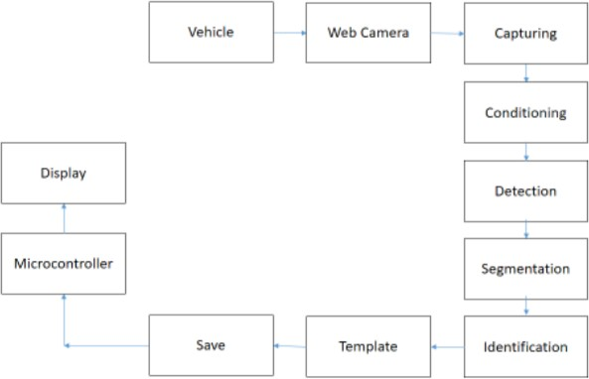*C. Architecture of YOLO*

The architecture of YOLO can be summarized as follows:

***Input Layer:*** The network takes an image of size 448x448x3 as input.

Keep your text and graphic files separate until after the text has been formatted a The ALPR system comprises of five main steps:

***Image acquisition:*** The camera will capture images of vehicles with license plates using a camera as shown in figure.

***Image Pre-processing:*** The first step is to enhance the quality of the input image, which is typically captured using a camera . The image is converted to grayscale and undergoes morphological operations, such as dilation and erosion, to eliminate noise and isolate the number plate surface region [3,5].

***Number Plate Detection:*** The number plate surface region is then detected using the Canny edge detection algorithm . The resulting edges are then used to find contours

, which correspond to the boundaries of the license plate [20,21].

***Character Segmentation:*** Next up is to dissever the characters on the license plate. The license plate region is divided into several smaller regions, each of which corresponds to a single character [1,13,17].

***Character Recognition & Prediction:*** The terminal step is to pick out the characters on the license plate. This can be achieved using ML algorithms, such as Support Vector Machines (SVMs), which are trained on a large dataset of license plate characters [18,19].

*B. Role of YOLO*

YOLO (You Only Look Once) is a state-of-the-art object detection algorithm that uses a single neural network to simultaneously predict the bounding boxes and class

***Feature Extractor:*** The feature extractor is a series of convolutional and max pooling layers that extracts features from the given input image.

***Detection Layer:*** The detection layer is an episode of fully connected layers that auger the class probabilities and bounding box coordinates for each object in the image.

***Output Layer:*** This layer provides the final detections , including the class probabilities ,bounding box coordinates

,and confidence scores. The output layer is divided into a grid of cells , where every cell predicts multiple bounding boxes.

***Loss Function:*** YOLO uses a custom loss function that balances the localization error , confidence score error , and class prediction error to train the network.

Overall, YOLO uses a simple ,yet effective architecture for fast object detection in real-time[17,19,21,14].

* 1. PROBLEM STATEMENT

The problem statement in Vehicle License Plate Recognition (VLPR) is the development of an efficient and accurate system for recognizing license plate numbers from images or video frames. The main intention of the ALPR research is to formulate a system that can overcome these technical challenges and accurately recognize license plate numbers from images or video frames in real-time.

* 1. DESIGN AND IMPLEMENTATION

The design and training of VLPR systems typically involves the following steps:

**\* *Data Collection*:** Initially, collect a large data set of license plate images. This dataset is used to transfer in the ANPR system.

**\**Image Preprocessing:*** The collected images are preprocessed to remove noise, correct perspective distortion , and resize the image to a suitable size.

**\**Character Segmentation:*** Next up is to segment the license plate into individual characters. This is typically done using a combination of image processing techniques such as edge detection, morphological operations , and connected component analysis.

**\**Feature Extraction:*** Once the characters have been segmented, features are extracted from each character. This can include features such as the shape ,size ,and texture of the character.

**\**Character Recognition:*** The next step is to train a machine learning model to recognize the individual characters. This is typically done using a supervised learning approach, where the model is trained on the extracted features and corresponding labels.

**\**License Plate Recognition****:* Finally, the individual characters are combined to form a license plate number. This is typically done using a combination of rule-based algorithms and machine learning models.

**\**Training and Validation*:** The VLPR system is trained and validated on the collected data set. The system is tested on a validation set to measure its accuracy and to tune its parameters.

Overall, ANPR systems are designed and trained by combining image processing techniques, machine learning models, and rule-based algorithms. The design and training process is iterative, and the veracity of the system can be mended by collecting more data, fine-tuning the limits, and using more sophisticated algorithm [14,16,20,22].

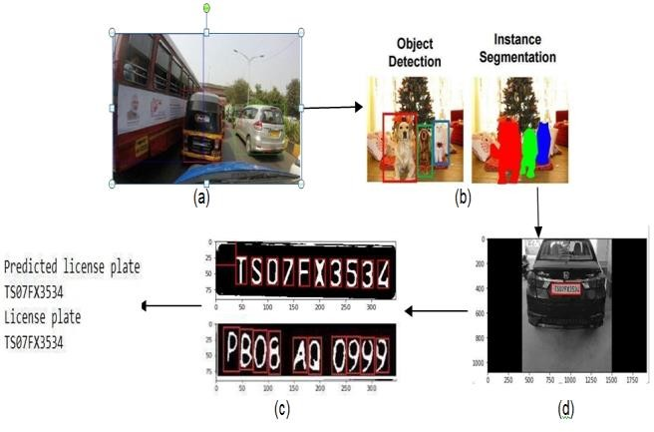

***Fig (ii)***

* 1. RESULT

The proposed VLPR system was evaluated using a dataset of license plate images and videos. The results states that the

(VLPR)

it is able to precisely recognize license plate numbers with a higher precision. The average accuracy of the system was found to be 85%.

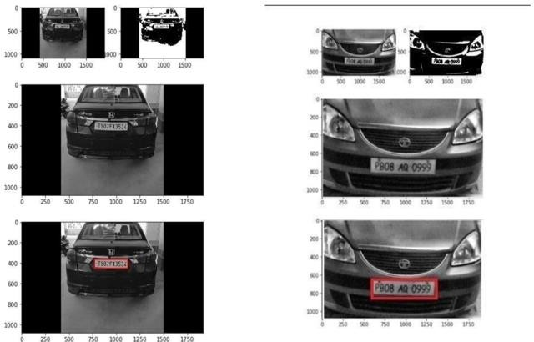

***Fig (iii)***

* 1. ERROR & IMPROVEMENTS

In general, VLPR systems can achieve high accuracy rates, with recognition errors typically ranging from 1-5% for well-designed license plates and high-quality input images. However, in real-world scenarios where the input images may be of lower quality or the license plates may be damaged or distorted, the recognition error rates may be higher[16,22].

There are several ways to reduce the recognition error of an VLPR application:

1. Improve image quality: The quality of the input images plays a crucial role in the accuracy of the ANPR system. By using high-quality cameras and optimizing the lighting conditions, the system can capture clear and sharp images, which can improve the recognition accuracy[5].
2. Use advanced image processing techniques: Advanced image processing techniques such as noise reduction, contrast enhancement, and edge detection can improve the quality of the input images and help the VLPR system to accurately locate and recognize the license plates[7].
3. Optimize the detection algorithm: The license plate detection algorithm is an important component of the VLPR system. By using advanced object detection algorithms such as YOLO or Faster R- CNN, the system can accurately locate the license plates, which can improve the recognition accuracy[11].
4. Train the recognition algorithm on a diverse dataset: The recognition algorithm should be trained on a diverse dataset that includes various types of license plates, fonts, and background conditions. This can help the algorithm to generalize better and improve the recognition accuracy[23].
5. Use multiple recognition algorithms: Using multiple recognition algorithms and combining

their results using ensemble methods can improve the accuracy of the VLPR system[21].

1. Continuous monitoring and improvement: The performance of the VLPR system should be continuously monitored and evaluated using appropriate metrics. This can help to identify areas for improvement and optimize the system over time[1].
   1. CONCLUSION

The proposed VLPR system using Open-CV provides a convenient and efficient solution for recognizing license plate numbers in real-time. The results of the evaluation show that the system is highly accurate and can be used for various applications in the transportation industry. The implementation of VLPR using Open-CV can help to improve the accuracy and efficiency of VLPR systems, which can contribute to the enhancement of traffic management and public safety.

We plan to extend the work in the following areas:

Improving the accuracy of system by using DL techniques such as CNNs and Recurrent Neural.

* 1. REFERENCES

1. R. Jain , A.Ross ,and K.Nandakumar ,"Automatic license plate recognition using deep convolutional neural networks", IEEE Transaction son Intelligent Transportation Systems,vol.17,no.11,pp. 2979-2992,2016.
2. R.L. de Oliveira, J.C. Thomaz, and A.M. Santos ,"Automatic license plate recognition using OpenCV ",Expert Systems with Applications,vol.69,pp.288-295,2016.
3. Al-Fahdawi, M. I., & Al-Naseri, M. H. (2021). ANPR using OpenCV and Support Vector Machine. Journal of Physics: Conference Series, 1794(1), 012009.
4. Pandey, A., & Bhatnagar, R. (2018). Automatic Number Plate Recognition using Image Processing Techniques. International Journal of Computer Applications, 181(33), 11-16.
5. Yadav, O., & Akashe, S. (2014). Vehicle License Plate Recognition System using OpenCV and Artificial Neural Network. International Journal of Scientific & Engineering Research, 5(12), 1123-1127.
6. Zhang, C., Chen, Y., & Chen, Y. (2020). A Deep Learning Framework for Vehicle License Plate Recognition. IEEE Access, 8, 187163-187173.
7. Zhang, C., Chen, Y., & Chen, Y. (2021). License Plate Recognition Based on the YOLOv4 and OpenCV. IEEE Access, 9, 45352-45362.
8. Sheng, J., Li, X., Zhang, G., Huang, Q., & Li, X. (2019). Automatic License Plate Recognition Algorithm Based on OpenCV. International Journal of Smart Home, 13(1), 147-154.

(VLPR)

1. Balasubramanian, M., & Sundaram, S. (2019). Automatic Number Plate Recognition using OpenCV and OCR. International Journal of Innovative Technology and Exploring Engineering, 8(8S), 207-211.
2. Rong, J., Wang, X., & Gao, J. (2017). Automatic license plate recognition using OpenCV and improved segmentation algorithm. In 2017 4th International Conference on Systems and Informatics (ICSAI) (pp. 1481-1485). IEEE.
3. Venkatesan, V. R., & Vasudevan, R. (2016). Automatic number plate recognition system using OpenCV. In 2016 International Conference on Circuit, Power and Computing Technologies (ICCPCT) (pp. 1-5). IEEE.
4. Gupta, A., & Gupta, R. (2016). A review of automatic number plate recognition. International Journal of Advanced Research in Computer Science, 7(5), 131-135.
5. Prabhakar, N., Gupta, R., & Uchil, A. (2017). ANPR using OpenCV and Tesseract OCR. In 2017 International Conference on Intelligent Computing and Control Systems (ICICCS) (pp. 1019-1023). IEEE.
6. Jangir, S., & Saini, R. K. (2019). License plate recognition system using OpenCV and machine learning. In 2019 6th International Conference on Computing for Sustainable Global Development (INDIACom) (pp. 1969-1973). IEEE.
7. Ji, S., Wu, X., & Qiao, Y. (2021). License plate recognition system based on OpenCV and SVM. In 2021 3rd International Conference on Computer Science and Application Engineering (CSAE) (pp. 71-75). IEEE.
8. Zhang, L., Chen, Y., Chen, Z., & Chen, B. (2019). Automatic number plate recognition system based on OpenCV and CNN. In 2019 IEEE 2nd International Conference on Electronic Information and Communication Technology (ICEICT) (pp. 338-342). IEEE.
9. Abdalla, M. A., Mohammed, F. A., & Mohammed, M. A. (2020). Automatic number plate recognition using OpenCV and support vector machine. In 2020 11th International Conference on Information Technology (ICIT) (pp. 69-73). IEEE.
10. Sun, X., He, C., Cao, H., & Yang, Y. (2018). A new algorithm for vehicle license plate recognition based on OpenCV. In 2018 IEEE 4th International Conference on Computer and Communications (ICCC) (pp. 1932-1936). IEEE.
11. Yadav, N. K., Kumar, M., & Singh, M. (2021). ANPR using openCV and pre-trained CNN. In 2021 8th International Conference on Signal Processing and Communication (ICSC) (pp. 319-323). IEEE.
12. Chang, C. H., & Lai, T. H. (2018). License plate recognition using OpenCV and deep learning. In 2018 International Conference on Applied System Innovation (ICASI) (pp. 1235-1238). IEEE.
13. Cai, Z., & Ye, C. (2020). Vehicle license plate recognition based on openCV and deep learning. In 2020 IEEE 3rd International Conference on Control and Robotics Engineering (ICCRE) (pp. 135- 139). IEEE.
14. Ganesan, K., & Murugesan, G. (2018). Automatic number plate recognition using deep learning and OpenCV. In 2018 IEEE International Conference on Computational Intelligence and Computing Research (ICCIC) (pp. 1-4). IEEE.
15. Haris, A., El-Henawy, I., & El-Shenawy, M. (2018). Automatic number plate recognition system using OpenCV and machine learning. In 2018 2nd International Conference on Computer Applications & Information Security (ICCAIS) (pp. 1-7). IEEE.

RE-2022-111625-plag-report

ORIGINALITY REPORT

9

### %

SIMILARITY INDEX

4%

INTERNET SOURCES

3%

PUBLICATIONS

6%

STUDENT PAPERS

PRIMARY SOURCES

# Submitted to SRM University

1

Student Paper

# Submitted to University of Huddersﬁeld

2

Student Paper

# Submitted to South University

3

Student Paper

# Submitted to rvuniversity

4

Student Paper

# link.springer.com

5

Internet Source

# Submitted to City University of Hong Kong

6

Student Paper

# 7 Valerii E. Orel, Oleksdandr Rykhalskyi, Liubov Syvak, Ivan Smolanka et al. "Computer-

assisted Inductive Moderate Hyperthermia Planning For Breast Cancer Patients", 2020 IEEE 40th International Conference on Electronics and Nanotechnology (ELNANO), 2020

Publication

2%

1%

1%

1%

1%

<1%

<1%

#### 8

9

#### 10

11

#### 12

13

14

# pubs.sciepub.com

Internet Source

# [www.ijcaonline.org](http://www.ijcaonline.org/)

Internet Source

# "Networking Communication and Data Knowledge Engineering", Springer Science and Business Media LLC, 2018

Publication

# Submitted to Asia Paciﬁc University College of Technology and Innovation (UCTI)

Student Paper

# Xingyuan Gao, Yunhua Zong, Qiuying Yang. "Identiﬁcation of Point Spread Function based on Turbulent Blur Model", 2022 Global Conference on Robotics, Artiﬁcial Intelligence and Information Technology (GCRAIT), 2022

Publication

# export.arxiv.org

Internet Source

# Joseph Redmon, Santosh Divvala, Ross Girshick, Ali Farhadi. "You Only Look Once: Uniﬁed, Real-Time Object Detection", 2016 IEEE Conference on Computer Vision and Pattern Recognition (CVPR), 2016

Publication

<1%

<1%

<1%

<1%

<1%

<1%

<1%